LAB PART 1

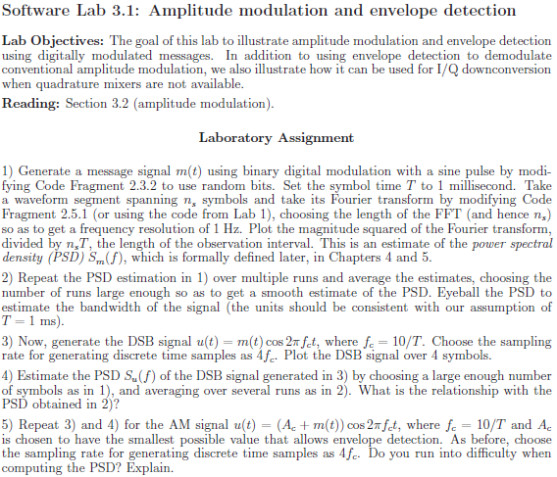

LAB PART 2

